HO Scale PRR Plain Keystone Boxcar Decals

This set provides enough lettering to do two 40’ and/or 50’ boxcars. Ten sets of specific dimensional data are provided for class X43B, X44A, X43A, X29B, X51B, and X52 boxcars. Additional classes (X29, X29D, X31A, X43C, X44B, X45, X46, X47, X48, X51, X55, and X56) are included to combine with the provided dimensional data for similar cars. (For instance, the dimensional data for a class X46 40' plug door boxcar is very similar to class X43B.) The letters A through L are included to allow the modeler to letter subclasses. A variety of scale marks and dates are provided to allow the modeler to change built and reweigh dates.

HO scale PRR Plain Keystone Decals, $4.50/set (enough for two cars) plus self-addressed stamped envelope, first class stamp, or cost of postage with included payment. The yellow CUSHION CAR lettering is also available for $0.50/pair (enough for one car).

Tom Haag, 351 Whitney Chase, N. Huntingdon PA 15642, haagtk@aol.com.
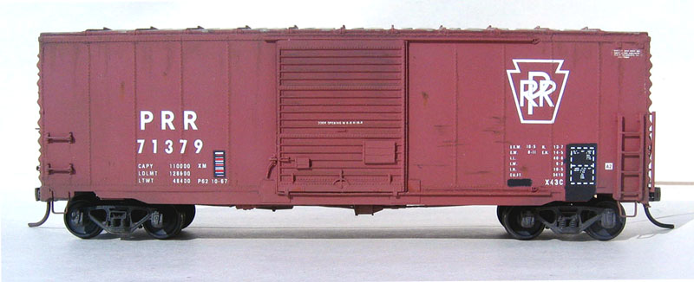

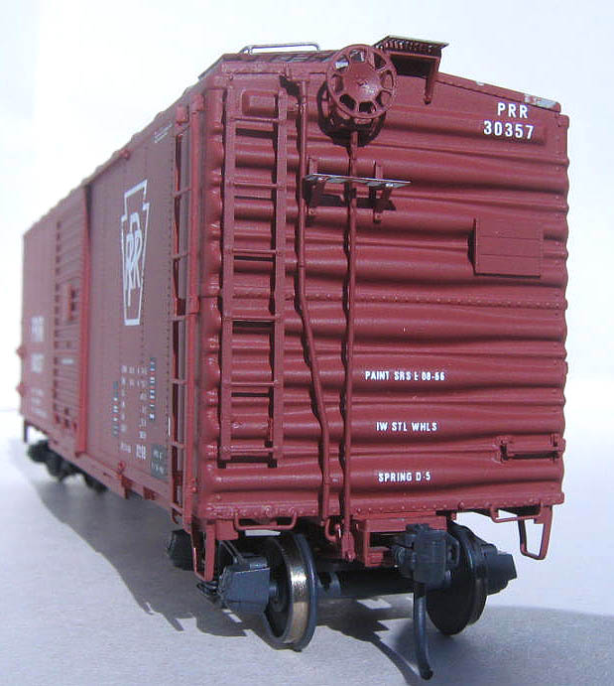
Branchline 40’ Boxcar lettered
with my PRR PK Decals.

End Vew.

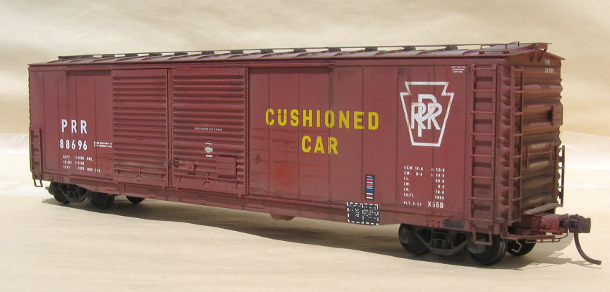

Kitbashed Branchline 50’ X56 Boxcar lettered with my PRR PK Decals.and the CUSHIONED CAR lettering.

